**Cllr BILL BORRETT**

**Annual Parish Report for the Elmham and Mattishall Division**

**April 2025**

**Devolution and Local Government Reform Update.**

The Government’s plan to impose one Mayor for Norfolk and Suffolk continues apace. They organised one face to face consultation event, which unbelievably was held in Ipswich and understandably there was hardly anyone from Norfolk in attendance.

The Government wants to hold the Mayoral election in May 2026 and the new Mayor will then need to charge a “mayoral precept” to cover the costs of the new Strategic Authority which they will run. This will be added to your Council Tax Bill in future years.

Even though it is being described as Devolution, it is taking powers from Breckland and the County Council rather than handing them down. For example: Strategic Planning will go up to the Mayor from Breckland. This is the call for sites and Local Plan that you may have been involved in.

Here in Norfolk we have launched a consultation independent of the Government, and if you have an opinion please take the time to go to <https://www.future-east.co.uk>

Your responses are important and will shape our response to the Government’s plans.

**Norfolk County Council opposes National Grid pylon scheme.**

I and my fellow County Councillors have objected to a National Grid proposal to construct an electricity transmission line across the county.

National Grid has launched a statutory consultation on plans for an 114 mile overhead power line between Norwich in Norfolk, Bramford in Suffolk and Tilbury in Essex.

In non-statutory consultations, Norfolk County Council has urged National Grid to reconsider the scheme, but the project will be determined by the secretary of state for energy security and net zero as a Nationally Significant Infrastructure Project.

Norfolk County Council’s planning and highways delegations committee have agreed to object to the proposal, arguing that alternative options, including an offshore or underground scheme, had not been adequately considered.

At a recent full council meeting, councillors backed a motion expressing concerns over the proposals.

That motion called for the Conservative-controlled council to write to National Grid with several requests, including further consideration of an offshore alternative and of putting more of the power line underground.

**Norfolk County Council set to receive highest highways maintenance allocation in the region.**

Norfolk is set to receive more than £56 million for highways maintenance this year.

Funding for every local authority across England today can be used throughout 2025/6 on the roads are in most need of repair, and to deliver immediate fixes for communities across Norfolk.

This comes just a few weeks after Norfolk took the top spot for the second year in a row in the National Highways and Transport (NHT) survey on roads and transport. People from across the county gave Norfolk the highest (above average) score in satisfaction with the condition of the highways.

More than 5,300 potholes have been fixed across Norfolk since April this year and of those 99% were repaired by our contractors within the agreed response times. If you see a pothole - don't assume someone else has reported it. Let us know by completing our online form:[**www.norfolk.gov.uk/potholes**](https://www.norfolk.gov.uk/potholes)

**Biggest yet Parish Partnership Scheme**

This month Norfolk County Council has reviewed a series of investments and improvements to the county’s highways infrastructure.

I’m really pleased that 97 parishes, from Antingham to Worstead, will benefit from projects funded through the Council’s Parish Partnership scheme. The 2025/26 programme is designed to deliver what local communities have requested, including trods (footways), village gateways, bus shelters, and vehicle-activated signs.

The programme is jointly funded by Norfolk County Council and contributions from Town and Parish Councils. This year, Norfolk County Council plans to contribute £425,476, enabling a total investment of £848,702 for local projects.

We have also reviewed the highways Capital Programme, which highlights successes from the previous year and outlines how highways maintenance funding will be allocated for the coming 12 months. This includes an additional £15 million from the Department for Transport (DfT).

With this extra funding, an additional 100 miles of roads in Norfolk will be resurfaced this year, supporting the Council’s proactive approach to highway maintenance that helps prevent potholes. The funding will also provide additional resources for local repairs and patching across the county.

**Norfolk County Council committed over £1m to keep people warm last winter**

Proposals to support some of Norfolk's most vulnerable people this winter have been agreed.

Norfolk County Council is looking to use £1.15m of the £6.7m allocated to the county through the Household Support Fund to keep people warm and help them make ends meet.

The county council will use £0.75m to partner with local organisations, including Age UK and Citizens Advice Bureau, to reach some of those most affected by the changes to the Winter Fuel Payments. They will also put £400k into the 'warm spaces' scheme which provides vital respite in community spaces across the county.

The proposals also include £3.6m to continue providing cost-of-living vouchers for families eligible for means tested free school meals. This is in addition to:

* £1.00m to Norfolk Assistance Scheme. Delivered by the Norfolk County Council, the scheme includes direct award of assistance, the provision of household items and emergency help, alongside a range of support and guidance
* £0.70m to local councils across Norfolk to provide proactive and crisis support
* £0.25m to Adult Learning to continue free access to a range of courses to help with cooking at home, budgeting, and digital skills.

**New strategy puts Norfolk at the forefront of the UK economy**

Norfolk's Economic Strategy, also known a Local Growth Plan, sets out an overview of the local economy and key priority areas for economic growth.

Norfolk is already at the forefront of some of the UK's most strategically important sectors.

Norfolk is a global leader for offshore wind with £39bn of clean energy investment forecasted over the next 20 years. In Great Yarmouth, the new Operations and Maintenance Campus is expected to create 650 new jobs and new commercial space for the offshore renewable energy sector. This £24.8m partnership project is a collaboration with Great Yarmouth Borough Council, with enabling works well underway.

Work is also underway to examine how to decarbonise the gas supply through the development of a 'Bacton Energy Hub', reusing existing North Sea assets for carbon storage, and blue/green hydrogen production.

The local Agri-Food and Agri-Tech economy puts Norfolk at the epicentre of addressing challenges around food security and climate change. Norwich Research Park is a world-leading research base at the forefront of global food and health research. It is Europe's largest single site hub of research, training, education, and enterprise in food and health.

Norfolk is already well known for a visitor economy which accounts for nearly 20% of all employment. The county was recently successful in bidding to become a Local Visitor Economy Partnership, alongside Visit East of England and Suffolk County Council. This put them on an even footing with the likes of Cornwall, the Peak District, and the Cotswolds who have the same level of Visit England accreditation.

Major infrastructure projects continue to transform how residents and businesses get around. The completion of the Herring Bridge and the start of construction on the long-awaited Long Stratton Bypass will bring a major boost for the local economy. Norfolk has also seen year-on-year growth in bus passenger numbers and the introduction of a major electric bus fleet.

The county council continues to push for improvements along the A47, with an ongoing campaign to improve connectivity and safety through further dualling in key areas.

Norfolk has built an increasingly enterprising culture, supporting residents to start up their own business, and for new start-ups to survive and thrive. Norfolk has a better than UK average for survival of new businesses at 63% after 3 years, compared to the UK average of 56%.

New Anglia Growth Hub acts as the 'front door' for local businesses looking for support. Over the past 10 years, the Growth Hub has supported over 14,000 businesses with free, impartial support and advice.

**Norfolk County Council supports Norfolk’s Family Farms**

We are taking proactive steps to support the county’s hard-working family farms in response to recent budget announcements from the Labour Government. Recognizing the essential role that farming plays in the local economy, the Council agreed a motion aimed at ensuring that Norfolk’s farmers are well-supported as they navigate the challenges brought on by these new policies.

The motion agreed the Council’s strong commitment to championing local businesses, with a particular focus on protecting the livelihoods of those who sustain Norfolk's agricultural heritage. Norfolk’s family farms are the backbone of rural communities, and the Conservative-led Council is dedicated to ensuring that their voices are heard and their concerns are addressed.

Understanding the issues that local farmers face, ranging from financial pressures to complex regulatory changes, the motion highlights the importance of offering practical support.

Norfolk County Council is committed to creating a future where local farmers can thrive, ensuring a sustainable and prosperous agricultural sector for generations to come.

**Discover the Best of Norfolk: Explore 1,500 Miles of Scenic Trails for Walking, Cycling, and Horse-Riding**

We have now established one of the best long distance footpath networks in the whole country. Norfolk offers over 1,500 miles of beautiful walking, cycling, and horse-riding routes, each showcasing the county's unique nature and rich cultural heritage. Whether you’re exploring tranquil river valleys, historic landscapes, or scenic coastal paths, Norfolk’s trails offer something for every adventurer.

Highlights include the **Angles Way**, a 93-mile walking route through woodlands and heathland, and the **Boudicca Way**, a 36-mile journey through ancient Roman and Iceni heritage sites. For those seeking to explore the Broads, the **Bure Valley Path** offers a 9-mile route along a heritage railway. History buffs will enjoy the **Kett’s Country Trail**, which follows the story of Kett’s Rebellion, while the **Peddars Way** takes you along an ancient Roman road.

Other stunning routes include the **Norfolk Coast Path** (a 112-mile National Trail), the **Marriott’s Way** (26 miles of scenic walking, cycling, and horse-riding), and the **Wherryman’s Way**, a 40-mile trek through the beautiful Broads National Park.

Whether you’re interested in history, nature, or simply exploring the countryside, Norfolk’s extensive network of trails provides the perfect way to experience this beautiful region.

For more information please visit [www.norfolk.gov.uk/article/42852/Norfolk-Trails](http://www.norfolk.gov.uk/article/42852/Norfolk-Trails)

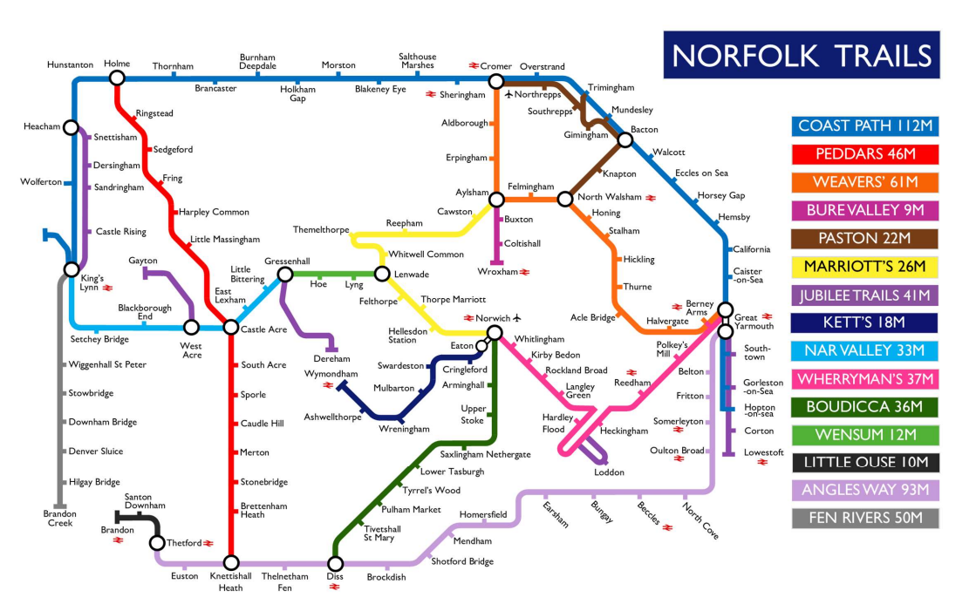

**Norfolk street lighting goes green**

We are leading the way in energy efficiency with the successful completion of a street lighting upgrade project, finishing almost a year ahead of schedule. This major initiative will cut CO2 emissions by over 200 tonnes annually, helping the county make significant strides toward a greener, more sustainable future.

The upgrade, carried out by Amey on behalf of Norfolk County Council, involved replacing 16,800 traditional High-Intensity Discharge (HID) lights with 15,531 state-of-the-art LED lanterns. This transition, which began in August 2023, will ensure that, starting in November 2024, 100% of Norfolk County Council's street lighting will use low-energy LEDs.

The final phase of this project will save approximately 1,099,032 kWh of energy each year, translating to an estimated £380,000 in savings based on current electricity prices.

Since the first LED streetlights were installed in 2008, the county has saved around 71 million kWh of energy, reducing carbon dioxide emissions by over 22,200 tonnes, equivalent to the carbon savings of 6.7 million litres of diesel. This project marks another significant achievement in Norfolk’s ongoing commitment to reducing its environmental impact and promoting energy sustainability.

**Council Delivers Balanced Budget and calls for cost-saving local government reorganisation**

As I have mentioned in previous Reports Norfolk County Council has approved a balanced budget for the 2025/26 fiscal year, despite facing considerable financial challenges.

**Key Details from the Norfolk County Council Budget:**

**Gross Budget:** The council has a gross expenditure budget of £2.2 billion (£1.7 billion excluding schools). This includes: £700 million for Adult Social Care, £367 million for Children's Services (non-schools), £283 million for Infrastructure, £44 million for Communities and Environment, £46 million for Fire Services

**Budget Growth:** The 2025/26 budget includes an increase of £121 million, which included: £31 million for inflationary pressures, £35 million for legislative pressures (including the increase in the National Living Wage and higher Employers National Insurance contributions), £15 million for demand and demographic pressures.

**Council Tax**:For 2025/26, Council Tax will increase by 4.99%, which includes a 3% rise for general Council Tax and a 2% increase for the Adult Social Care precept.

**Working Well Norfolk helping people with long-term health issues to keep working**

A scheme to support people in Norfolk with long-term health issues get back into employment or continue in their jobs has already helped more than 1,100 participants.

The Working Well Norfolk programme, launched in October 2023, supports individuals with long-term health issues to return to or stay in work. It has already helped over 1,100 participants, with 200 moving into work and 150 staying employed despite health challenges. The programme has received 1,600 referrals and will continue for another 18 months, with additional funding to help 730 more people, totalling 1,830 participants by September 2026. The £5.2m project is managed by Norfolk County Council and delivered by Seetec Pluss and Standguide Ltd. For more info or to refer, visit [**Working Well Norfolk - Seetec Pluss**](https://www.seetecpluss.co.uk/working-well-norfolk/) or call 01603 561054.

**Norfolk signs historic agreement with Ukrainian region of Lviv**

A cooperation agreement has been signed between Norfolk County Council and the Ukrainian region of Lviv which is designed to explore knowledge transfer, educational exchange and trade opportunities.

The historic Memorandum of Understanding (MoU) was signed on Thursday 2 May at the Ukrainian Embassy in London by Leader of Norfolk County Council Kay Mason Billig and in Lviv via video link by Maksym Kozytskyi, Head of the Lviv Regional Military Administration. It is the first such agreement to be signed with Lviv by any part of the UK.

Cllr Mason Billig was joined at the ceremony by Liz Truss MP, as the MP for for South West Norfolk, Cllr Fabian Eagle Cabinet Member for Economic Growth, Cllr Chris Dawson, Rural Champion, Chris Starkie, Director of Growth and Investment, and Roberta Willner, Head of Economic Development. Also there to witness the signing of the agreement was Nataliya Klymko, Programmes Coordinator for Growth and Investment.

Both Norwich and Lviv have links to UNESCO: Norwich is a UNESCO City of Literature, and the historic part of Lviv city (300-acre historic centre) is included in the UNESCO World Heritage list. In 2022, Lviv was granted Freedom of the City of Norwich in solidarity with Ukraine, and the MoU - similar to a twinning arrangement - will further celebrate and build on these links.

Norfolk and Lviv have identified several key opportunities for collaborative working, including the TechBridge programme, a strategic partnership between the UK Government, Ukraine Ministry of Digital Transformation and Ukraine Ministry of Foreign Affairs to forge connections between our tech ecosystems.

This partnership currently runs to 2025 but may be extended, providing businesses in both locations access to expert advice and support in navigating the barriers to UK-Ukraine trade. There are also specialist investment accelerator programmes for Ukraine tech SMEs looking to expand overseas.

The skills and knowledge the local Lviv tech sector offers are recognised on the international level. For example, Lviv IT specialists developed the Skype app and special effects for films such as Harry Potter and Spider-Man. Norfolk also has a strong growing ICT/Digital sector with several individual clusters, and the MoU will encourage collaboration within the sector between our regions by participating in mutual events of interest.

This not only benefits cluster growth in a key sector for Norwich and Norfolk's digital services and would benefit Lviv through the contribution to the recovery efforts.

Other opportunities for collaboration include an incoming visit to the Theatre Royal Norwich in October by the Lviv National Philharmonic Orchestra of Ukraine, led by leading conductor, Theodore Kuchar.

**Herring Bridge receives further national awards**

The new Herring Bridge in Great Yarmouth, which opened in February, received further national recognition at a Highway Awards ceremony in London last night.

Norfolk County Council's nationally significant infrastructure project won the Major Project of Year award and was also later announced as winner for the Highways Special Merit award across all shortlisted finalists.

This follows the bridge already receiving Major Project of the Year at the New Civil Engineer awards early this summer.

The Highway Awards were held on Tuesday 24th September at Park Plaza, Westminster Bridge in London, with shortlisted entries decided by an expert panel of twelve judges.

Norfolk's entry was a joint submission with consultants WSP who worked with the council and partners to take the project, constructed by BAM Farrans joint venture, from its inception through to delivery.

**Thank you for your interest. If you have any queries please do not hesitate to email me on:** [**bill.borrettcllr@norfolk.gov.uk**](mailto:bill.borrettcllr@norfolk.gov.uk)

Best Wishes

Bill

**BILL BORRETT**