Cllr BILL BORRETT
Parish report for the Elmham and Mattishall Division
February 2026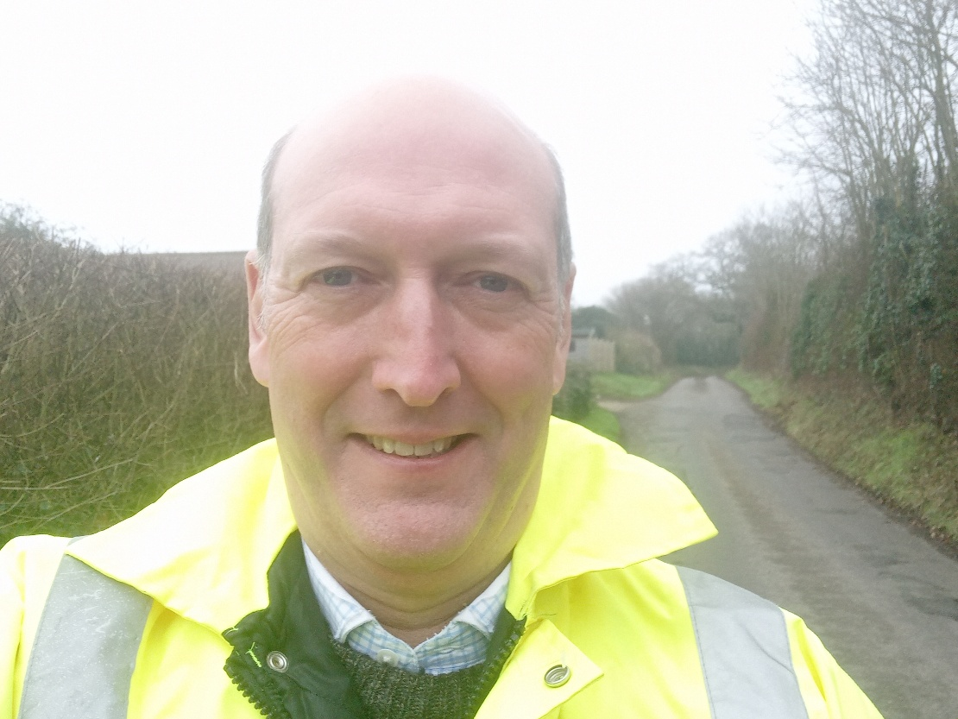

County Council Elections Cancelled by the Government
You may have seen in the news that Steve Reed MP the Secretary of State for Local Government has stated that it is his intention to cancel the Norfolk County Council elections due in May 2026. This is outrageous and I have lobbied the Minister (with many other Councillors) on your behalf to get him to re-consider his decision, but to no avail. This means that the next Local government Elections will be held in May 2027 instead.
The Minister will announce next month what the future of Norfolk will look like when he abolishes Norfolk County Council and Breckland District Council. I hope that he will have listened to the huge amount of feedback from Breckland’s residents in favour of three Unitary Councils as opposed to the huge single council for Norfolk of nearly 1m people.
It is interesting times for local services, and I commit to you that I will continue to fight to make sure that those of us here in Breckland don’t end up funding the mistakes of other less well-run Councils in the future.

Norfolk gritting vehicles head out over winter season
Norfolk County Council's winter gritting is of course underway, with gritters active on A/B roads, key bus routes, and village access roads, using new tech for efficiency. The first runs of the recent winter season (late 2025/early 2026) started as temperatures dropped, utilizing the 58-strong fleet with automated salting to cover 2,200 miles of routes, supported by stocked salt barns and public grit bins.
Updates are posted on their social media using #NorfolkWinter, with a dedicated website for info, and recent campaigns even involved naming the gritters. Residents can also check this year’s gritting routes using the online map on the council’s website
(https://maps.norfolk.gov.uk/highways/maps/gritting.aspx)
If you’d want to report any gritting issues please contact the Report a Highways Problem section on the Norfolk County Council website
(https://www.norfolk.gov.uk/article/63696/Report-a-highways-problem)

Norfolk County Council takes first place in the Eastern region in annual Highways and Transport Satisfaction Survey
Norfolk County Council has once again demonstrated strong performance in the National Highways and Transport (NHT) Public Satisfaction Survey, taking the top spot in the Eastern region for overall satisfaction and second out of 29 county councils across England.
This marks the 15th consecutive year Norfolk has participated in the survey, and the 7th year in a row that we have come either first or second overall.
Key highlights from this year's results include:
- Top Regional Performer: Norfolk ranked 1st in the Eastern Region for overall satisfaction.
- Some of the best above average score were in our bus services thanks to improvements that have been made as part of our Bus Service Improvement Plan. The 'local bus services' overall category we were 10% above the group average with sub indicators as follows:
Frequency of bus services (9% above group average) and Condition of highways (8% above group average)

Norfolk has secured a multi-year funding boost for highways and bus services
Norfolk County Council has welcomed two major funding announcements from government, providing long-term certainty for highways maintenance and bus services for the first time in many years.
The multi-year settlements will allow the council to plan with confidence and deliver programmes of work that join up different funding streams to maximise impact for residents and businesses.
The council has received confirmation of its highway's maintenance funding allocations through to 2029/30. Funding will rise from £56 million in 2025/26 to over £83 million by 2029/30 - a £27 million increase over the period.
Norfolk's future bus grant allocations have also been confirmed, covering both revenue (for services) and capital (for schemes) funding through to 2029/30. Annual funding for bus services across Norfolk will now exceed £15 million.

Connect to Work to support more than 4,000 people facing barriers to employment
People in Norfolk with disabilities and long-term health issues that are keeping them out of employment are to receive support from the newly launched Connect to Work programme.
The scheme aims to build on the achievements of the previous Working Well Norfolk and Local Supported Employment projects and reduce the county's higher than average economically inactive population.
In Norfolk, 109,100 (20.6%) of individuals aged 16-65 were classed as economically inactive in 2024 - 1.5% higher than post-covid - and 30,100 (27.7%) were classed as having long-term sickness, compared with 23.7% in 2019. This is higher than the East of England figure of 25.9% and the UK average of 27.2%.
Connect to Work is aimed at people aged 18 and over from Norfolk (and 16-17 in some cases) from a wide range of cohorts.
People who are in work but at risk of having to give up due to their health condition or other complex challenges will also be assisted.
To find out how to access support via Connect to Work, please visit www.norfolk.gov.uk/workingwell or email us on connecttowork@norfolk.gov.uk

Made Smarter funding for region' s manufacturing businesses set to double
Advanced manufacturing small and medium enterprises (SMEs) in the East of England are set to receive more support to grow and innovate after the Government agreed to double its funding for the Made Smarter Adoption (MSA) programme.
The programme will deliver funding, impartial advice, a roadmap from digital specialists, and leadership and management development programmes to upskill workforces. Norfolk County Council will also be responsible for delivering and processing 48 match-funded grants delivered up to £20k.
A successful pilot has seen Norfolk County Council lead a £1.2m programme in 2025/26, supporting more than 88 SMEs in the region with digital support and roadmaps for implementation, leadership and management, organisational change. Funding for a £2.4m programme for 2026/27, with the potential for a significant increase in future years, has now been confirmed - subject to Government funding and performance.
Norfolk County Council's cabinet agreed the funding and to the council being the accountable body for the programme when it met on 5th January 2026.

New specialist fire service vehicles for Norfolk
Two new state-of-the-art specialist vehicles are being delivered into Norfolk later this month, leading the way in technology and ability across the fire and rescue sector in the UK.
The water and foam carriers can hold and pump 13,500L of water, 1,500L of foam concentrate, making them among the largest and most capable vehicles with specialist equipment to enhance firefighting operations.
Built by Emergency One in Scotland, the cost of the two water carriers is £850,000 and replace two ageing and smaller carriers which are 23 and 24 years old.

Have you taken on the 30-day health challenge in 2026?
Norfolk County Council is encouraging residents across Norfolk and Waveney to kick start the new year by signing up to the 30-day health challenge, a simple and supportive way to make positive changes to health using the free online Ready to Change tool.
The challenge is designed to help people make realistic, achievable lifestyle changes over 30 days; a timeframe which experts say is far more manageable than aiming for drastic, long-term change all at once.
Visit www.readytochange.co.uk to find out more about the 30-day health challenge, take health quizzes and sign up for expert health guidance and support to get you the success you deserve in 2026.
How do I get involved in the 30-day health challenge?
Step 1: Visit the Ready to Change website and choose one of the following health challenges:
- Aim for a healthier weight
- Drink less alcohol
- Quit smoking
- Eat more healthily
- Be more active
Step 2: Sign up to receive free weekly expert health guidance, tips and support by email over the next 30 days.

Thank you for your interest. If you have any queries, please do not hesitate to contact me on bill.borrett.cllr@norfolk.gov.uk
With my best wishes
Bill
BILL BORRETT
Member for the Elmham and Mattishall Division
Norfolk County Council

