Cllr BILL BORRETT
Parish Report for the Elmham and Mattishall Division
March 2026

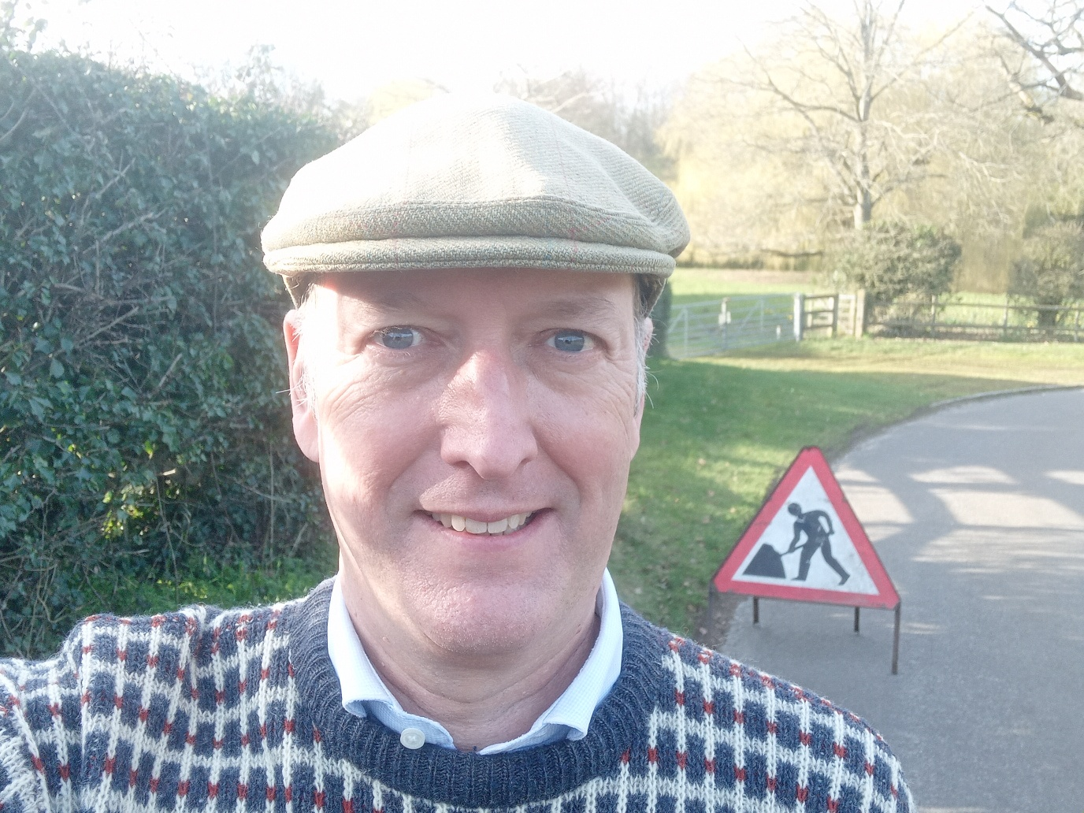

Welcome, there is much to report from Potholes, Rural Business Awards to Elections:
Highways
I have had reports from Villages all over the Division about the state of the rural roads. You know what they are like in your parish, but some of the worst hit are those near the A47 Dualling Works. They are suffering large volumes of diverted traffic (especially HGVs) from Lyng to the north and North Tuddenham to the south.
I have met with the Highways Department, including the Director of Highways for the whole of Norfolk, and shown them some of the worst affected areas. I am told that the wet weather has made it impossible to do permanent patching. However, I am very keen to agree a plan that alleviates the current problems for villages together with some proper solutions for later in the year.

On/Off Elections finally back on for 7th May
I am really pleased to announce that the Elections for all 84 divisions of Norfolk County Council will now go ahead on 7th May, following a huge amount of pressure on the Labour Government who had decided that they were going to cancel them. I have been very strident in my opinion that they needed to go ahead. The principle of democracy is much more important than the domestic projects of the Labour Party.
I have always spoken up for the Parishes of the Division above Party Politics, and this principle is no different.
(Further details of the Government’s decision can be found in its published statement on the postponement of local elections in England in May 2026).

Norfolk County Council delivers balanced and responsible budget for 2026–27
Providing Value for your Council tax is vitally important and in February Norfolk County Council approved a balanced £613.8m budget for 2026–27, demonstrating strong financial leadership and prudent management in what remains one of the toughest funding climates in decades, despite the Government cutting the Rural Services Delivery Grant for Rural Areas like Norfolk.
County Council has once again delivered stability and certainty for residents, setting a balanced financial position while identifying £42.3 million in savings and efficiencies and committing £76.3 million in targeted investment to protect vital services and strengthen Norfolk’s economy.
Despite significant national financial pressures and ongoing constraints in central government funding, Norfolk’s Conservative administration has ensured the county remains on a firm financial footing, without resorting to emergency measures. This stands in stark contrast to a growing number of upper-tier authorities across the country that have issued Section 114 notices or are facing effective bankruptcy.
The budget enables the council to continue:
- Protecting frontline services
- Investing heavily in adults and children’s services
- Delivering new libraries and modern learning hubs in key towns
- Supporting for heritage, culture, and tourism
- Driving transformative reforms to improve efficiency and outcomes
- Backing economic growth and infrastructure
- Maintaining long-term financially sustainability
Councillors also agreed a 4.9% council tax increase, in line with national funding assumptions and the continued reliance on local taxation to safeguard core services. Norfolk Conservatives have been clear that this decision reflects the financial realities facing councils nationwide, while ensuring essential services remain protected for Norfolk residents.

Norfolk County Council invests in community led highway improvements across the county (The Parish Partnership Scheme)
Norfolk County Council has reaffirmed its commitment to supporting local Parishes with the approval of 99 new highway improvement schemes for 2026-27, delivered in partnership with town and parish councils across Norfolk.
The Parish Partnership Scheme, now entering its fifteenth year, gives Parishes a voice in shaping the highways enhancements that matter most to them, whether that's improving pedestrian safety, slowing vehicle speeds, or making it easier to walk, cycle or access local services.
This year's programme represents a total investment of £769,034, made possible through the longstanding 50/50 funding model. Town and parish councils will collectively contribute £384,517, matched by £384,517 from Norfolk County Council, enabling more than twice as many small-scale schemes to be delivered than could be funded by the council alone.
In total local councils submitted 99 bids for 2026/27 and all were approved as viable schemes after being carefully assessed against value for money, community outcomes, safety benefits and compliance.
The programme will deliver across the county from Ashill and Attleborough to Wymondham and Weybourne and include;
- 68 small highway improvements - such as village gateways, new trods, signage, surfacing, benches, and access improvements
- 31 vehicle activated speed sign (VAS/SAM2) projects, helping encourage safer speeds through villages and towns. The County Council has stepped in to fully support this part of the programme following the withdrawal of previous funding from the Safety Camera Partnership
The full report including a list of all 99 schemes can be found from page 788 in the cabinet papers online.

Norfolk County Council launches the 2026 Rural Business Awards
Please nominate any local business that you think should be considered. (Details below).
Norfolk County Council is once again shining a spotlight on the county’s outstanding rural enterprise as nominations open for the prestigious Norfolk Rural Business Awards 2026.
From pioneering food and drink producers to forward-thinking farming innovators and dedicated community champions, the awards celebrate the very best of rural Norfolk. Businesses, individuals and organisations are invited to apply across nine categories, with finalists honoured at a special ceremony during the Royal Norfolk Show in June.
Now firmly established as a highlight of Norfolk’s business calendar, the 2026 awards were officially launched on 10th February at the Norfolk Farming Conference, underlining the council’s ongoing commitment to supporting and championing the rural economy.
Delivered by Norfolk County Council in partnership with the Royal Norfolk Agricultural Association, the awards recognise excellence, innovation and resilience across the county’s diverse rural sectors. The council continues to work closely with partners and sponsors to ensure rural businesses receive the recognition they deserve.
Each category will be judged by a specialist panel, who will review applications and follow up with shortlisted nominees before selecting the winners. The closing date for entries is Tuesday 21st April.
Winners will receive a trophy and certificate, as well as the opportunity to use Norfolk Rural Business Awards branding in their promotions, a mark of excellence backed by Norfolk County Council.
The categories are:
- Best Rural Community Initiative - sponsored by Pearn Wyatt Transport Ltd
- Best Rural Innovation in Practice - sponsored by Birketts
- Best Food and Drink Producer - sponsored by Fountain Fresh Imports
- Norfolk's 'Unsung Hero' - sponsored by Poultec
- Best Food and Farming Champion - sponsored by CLG Norfolk
- Best Emerging Talent - sponsored by PlantGrow
- Best Rural Tourism Attraction - sponsored by Thursford
- Best Woman in Agriculture - sponsored by Lovewell Blake
- Best Rural Business - sponsored by New Anglia Growth Hub
Find out how to apply by visiting:
www.norfolk.gov.uk/business/norfolk-rural-business-awards.

Norfolk County Council back hospitality with £250,000 support programme
Norfolk County Council is delivering targeted support for the county’s vital hospitality sector, launching a £250,000 package at the Norfolk Market Towns Conference as part of a wider £1m investment in high streets.
More than 120 retailers and organisations gathered at Thursford to shape the future of Norfolk’s market towns, highlighting the council’s proactive, partnership-led approach to supporting local businesses.
Building on the success of the council’s High Streets Matter initiative, the new programme will offer bespoke training for pubs, restaurants, hotels and independent retailers. Businesses can access practical workshops, both in-person and online, covering marketing, bookings, menu development and staffing, alongside business improvement grants of up to £1,000.
A further High Growth Programme will support 24 ambitious businesses with specialist advice and grants of up to £2,500 to help grow the next retail and hospitality success stories.
Additional Love Your Market Town grants will help businesses boost civic pride, increase footfall and celebrate what makes their town unique, while Retail Excellence courses are also available for non-hospitality high street businesses.
This investment underlines Norfolk Conservatives’ commitment to backing local enterprise, strengthening market towns and ensuring Norfolk’s high streets remain vibrant, resilient and ready to thrive.

Boost for water safety as new rescue boats arrive
Norfolk Fire & Rescue Service has taken delivery of six new Zodiac Milpro ERB400 rescue boats to strengthen its response to water emergencies across the county.
The boats will support rescues on inland waterways and the Broads, as well as assist during major flooding incidents. They will replace ageing vessels at King’s Lynn, Great Yarmouth, Dereham and Carrow fire stations, with an additional boat based at the Training and Development Centre in Bowthorpe to enhance in-house training.
Crews will complete familiarisation training before the new fleet becomes fully operational. The investment modernises equipment that was more than 18 years old, ensuring firefighters are equipped to respond quickly and safely.
Norfolk Fire & Rescue Service will continue working with partners through the county’s Water Safety Forum to educate the public about staying safe around water. In any coastal emergency, residents should call 999 and ask for HM Coastguard.

Thank you for your interest. If you have any queries. Please do not hesitate to contact me on bill.borrett.cllr@norfolk.gov.uk or bill.borrett@hotmail.co.uk

With my best wishes
Bill

BILL BORRETT
Member for the Elmham and Mattishall Division
Norfolk County Council

