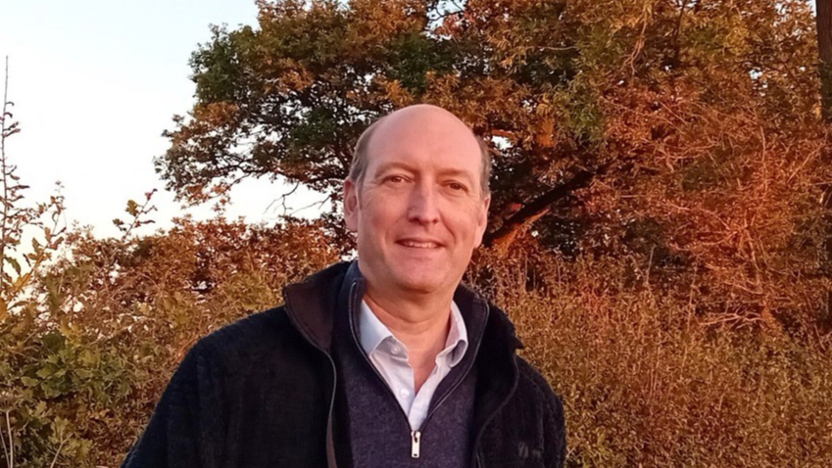

Cllr BILL BORRETT
Parish report for the Upper Wensum Ward
July 2026

Update
I am sure that you are aware that there is a newly elected County Councillor for the Parish, I am still one of your two District Councillors for the Upper Wensum Ward, accordingly I have slightly changed my Parish Report, and it will now mainly focus on issues that Breckland is involved with.

Food Waste Collections
The Government has decided that ALL Councils will now have to have separate Food Waste Collections (the extra cost of which will be borne by the Council Tax Payer). Breckland is therefore making arrangements to introduce this new Service and you will be seeing some changes with your bins.
Every household will have to be given 2 new Food Caddys. They are small BLUE bins, one to keep in your kitchen and the other, slightly bigger one, will live outside with your other bins.
The small one to be used to fill the bigger one, which you will need to put out EVERY week, probably on your bin day. It will be collected but not at the same time as your main bin because it will be being collected by a different lorry.
There is a lot to take in, so everyone will receive a leaflet with your new bins, there will be a video on the Breckland website and there will be Open Days at Breckland’s Offices for people who want to learn more.
The Government is keen for the collection to begin as soon as possible so the new bins/caddys will start appearing in August and the first Collections are due to begin in September.

Breckland Local Plan
The new Local Plan is progressing.
You will know that the Labour Government doubled the number of houses it has instructed Breckland to provide in its Local Plan (without any local consultation). This has meant that it is having to be re-done before May 2027. It will cover the period 2025 to 2043.
There was a Planning Inspectorate Visit on 14th May and they announced that they are happy with the progress so far. It is coming back to Breckand’s Cabinet Meeting on 13th July for the progress so far to be agreed and to start the following stage. The papers for the Meeting will be published on the Breckland Website on the 2nd July.

Local Government Re-Organisation (LGR)
There is some confusion over the progress with LGR due to the problems the Government is having in Westminster. There is a lack of activity which is being attributed to the fact that there is likely to be a reshuffle of Ministers when the Prime Minister steps down and nobody knows whether this will still be a priority of the new Leader.
Tom McCabe, the Lead Officer who is supposed to be leading the various workstreams here in Norfolk to deliver LGR has just resigned and will leave immediately. That being said, there is no official change to the Government timetable for LGR to be delivered.
I have serious concerns that without clear action from the Government it will be impossible for it to be delivered without it being a shambles!

Migrant Re-settlement in Breckland

You may have heard that the Government/Home Office moved some migrants into Watton without notifying Breckland or the Local Community. Now that the policy of using hotels has been abandoned, they are renting houses and putting migrants in them in the various communities across the County. It is difficult to support them with the services that they will need if we do not know that they have arrived.
Breckland, is the local Housing Authority and has not been any part of these processes. The Leader has written to, and tried to meet with, the Home Office, so far with very little response. He has committed to keep all of Beckland’s residents up to date with everything that Breckland hears as soon as we are made aware.

Please do not hesitate to contact me if you have any questions.
My email address is: bill.borrett@breckland.gov.uk
With my best wishes

Bill
BILL BORRETT
Member for the Upper Wensum Ward
Breckland District Council

